**PROJECT REPORT**

1. **Introduction**

The project selected by my team is Unveiling Marketing insights.

1.1 Over view

* Analysing spending behaviour and identifying opportunities for growth of the unveiling market

1.2 Purpose

* To improve the wholesale of the market

1. **Problem definition & design thinking**

2.1 Empathy Map

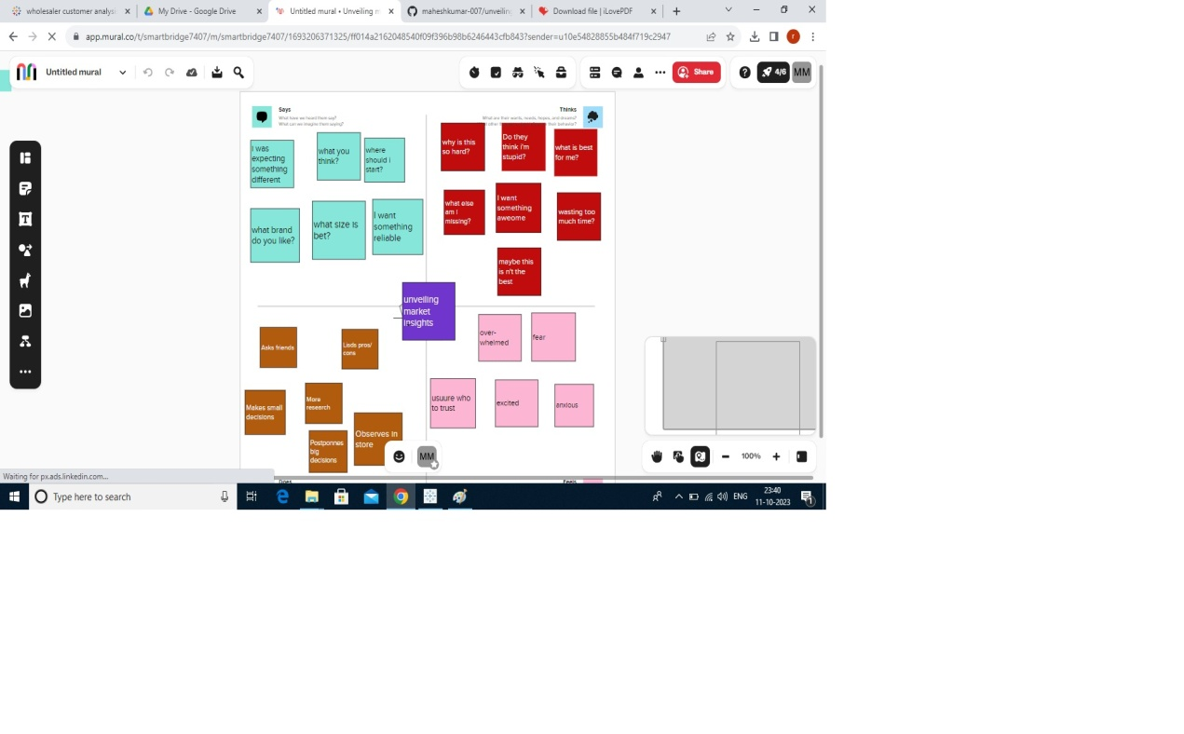

2.2 Ideation & brainstorming

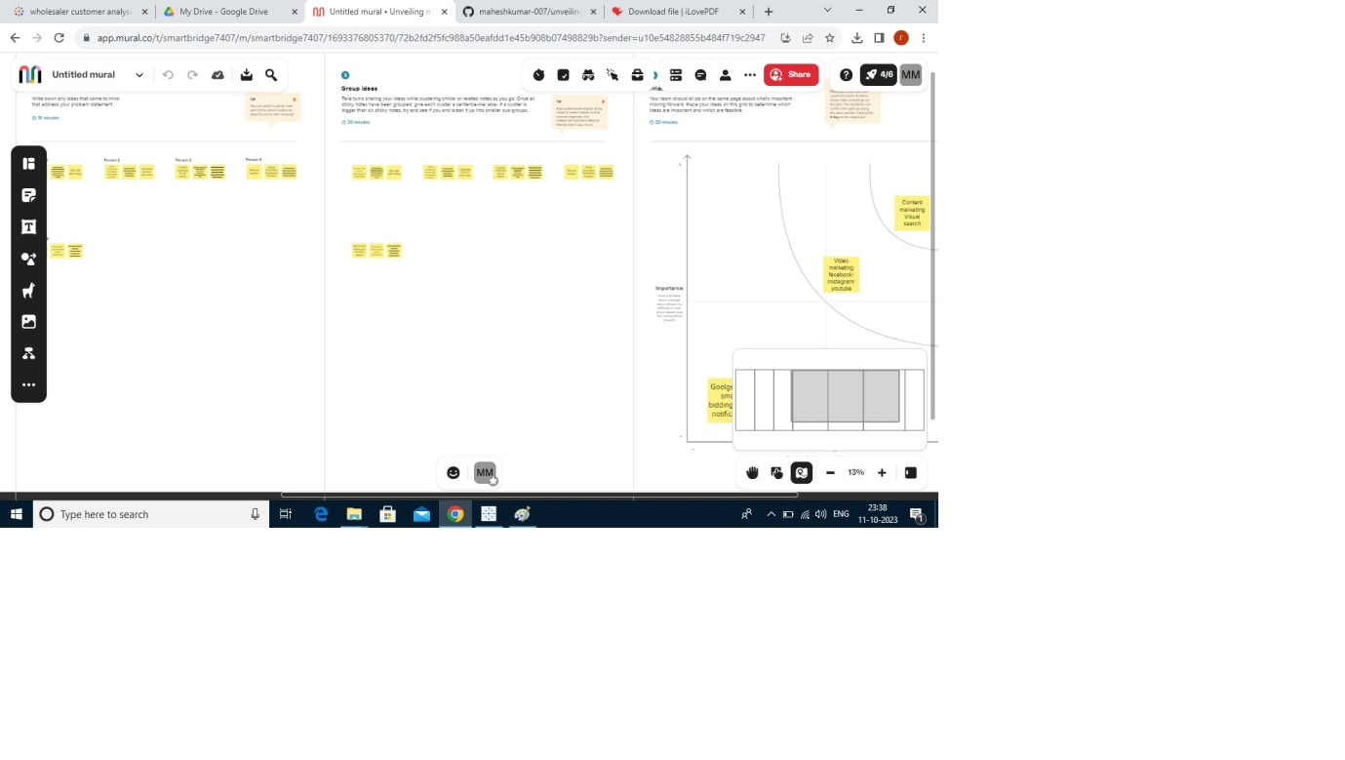

1. **Result**

Dash board

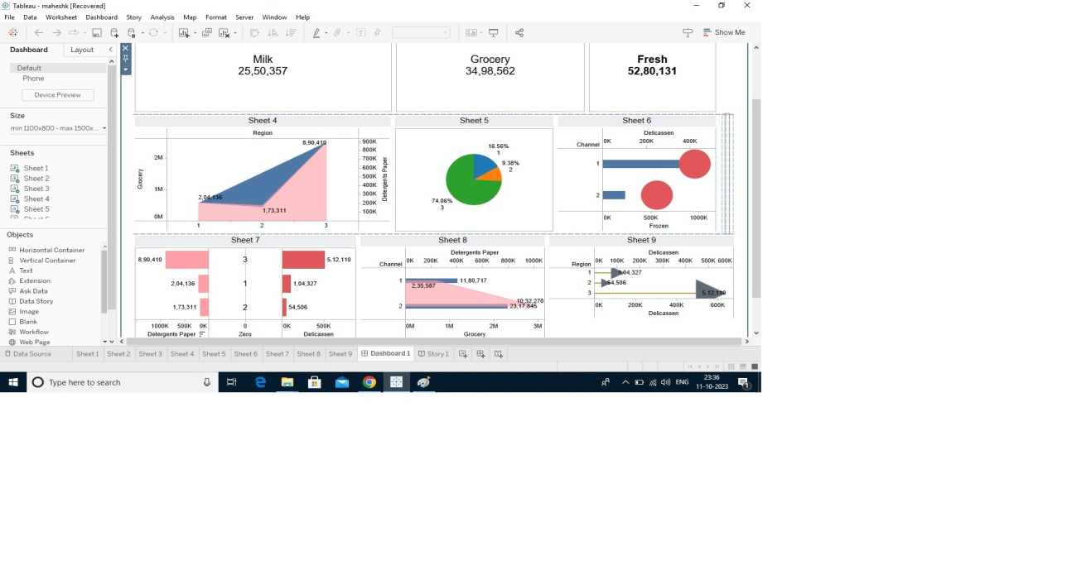

Story

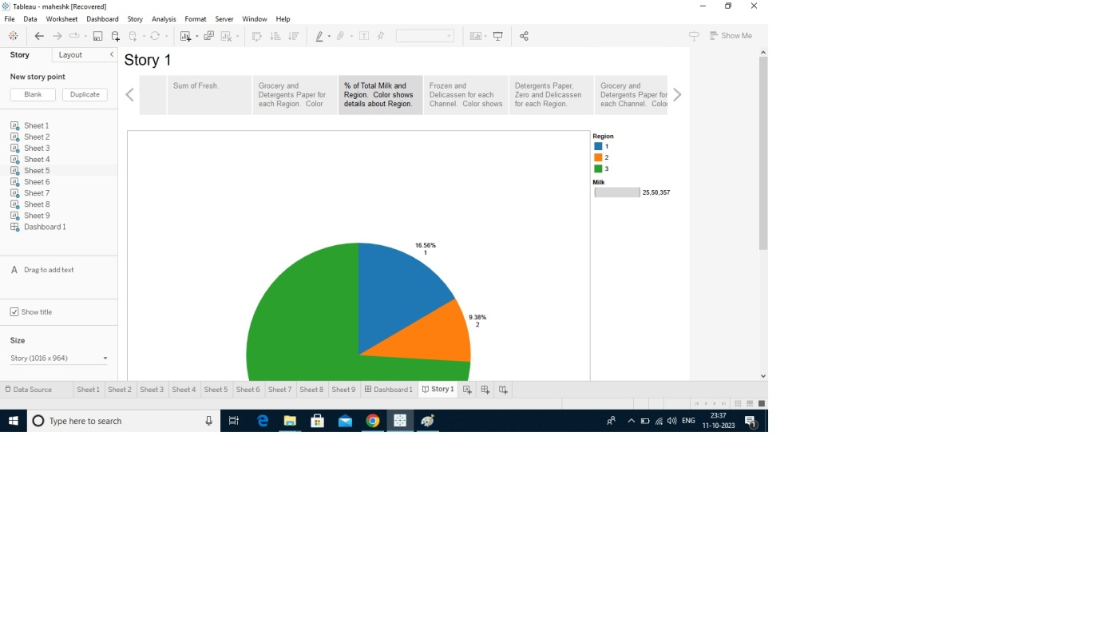

1. **Advantages & Disadvantages**

* It is very useful to analyse the data and get reports and results for the specified problem
* There is no disadvantages by using tableau

1. **Applications**

* It is very useful in marketing, data analysing, and data interpretation.

1. **Conclusion**

* By this analyse using Tableau, the unveiling market business can optimize their marketing strategies and improve their product offerings and enhance customer engagement to drive revenue growth

1. **Future Scope**

* By using Tableau we can easily know our strength and weakness in our business. In future it will lead a major role in data analysing.